**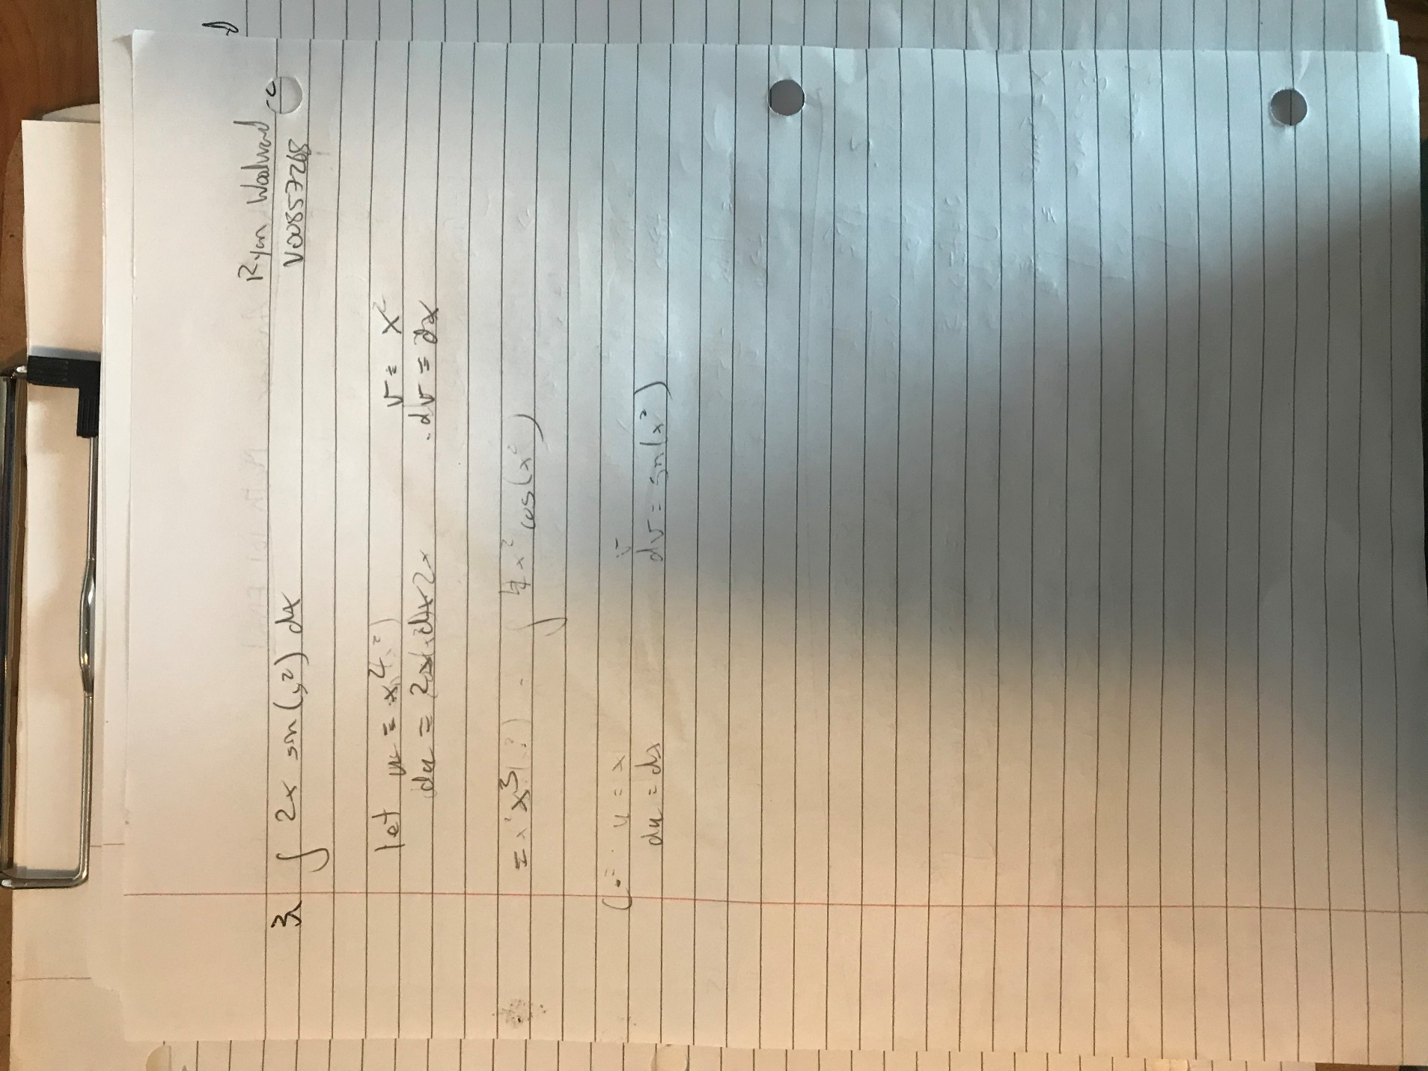

**Math 101 Long Answer Section**

